Wydział Inżynierii Metali i Informatyki Przemysłowej

*Multiscale Modelling - Report*

Robert Przybek IS SN

1. First of all I have GUI, but not to customization. I implemented static size in windows design 433x409. I use C# programming language. Unfortunately I not implemented import/export to bmp/txt.

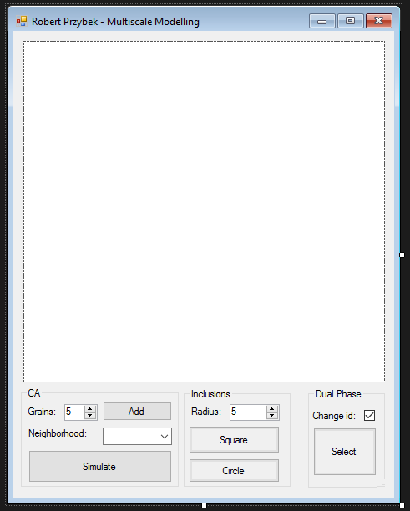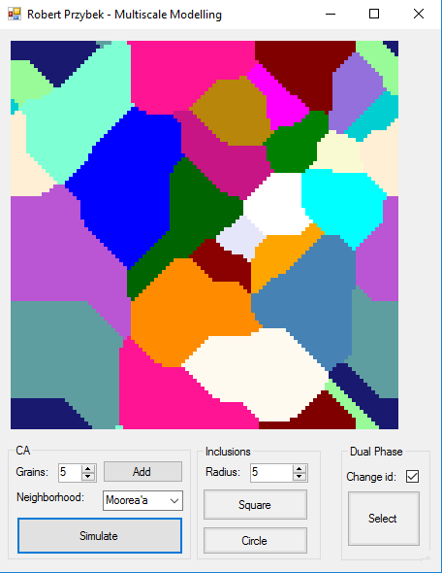

When you click button “Add” you added number of grains, you can also choose neighbourhood and then you click button Simulate and simulation should be works like as above right picture.

If you want mark some colours, only what you can do is click button “Select” next choose colours what you want and click button “Select” once again.

You can also add after that new grains and start new simulation.

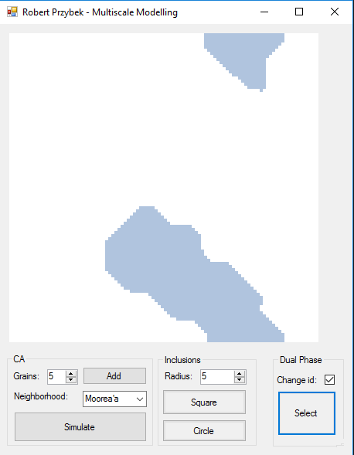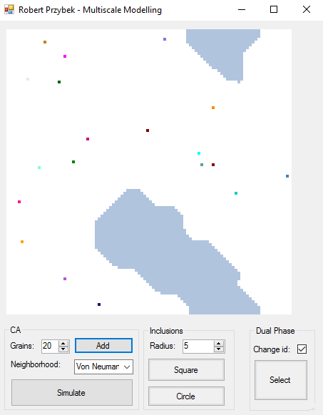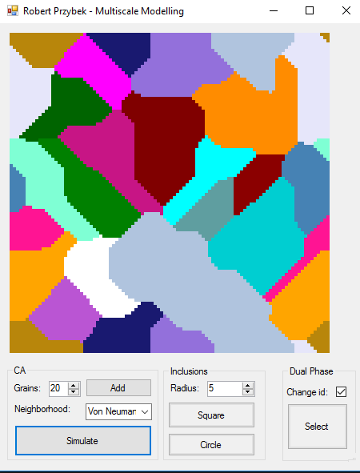 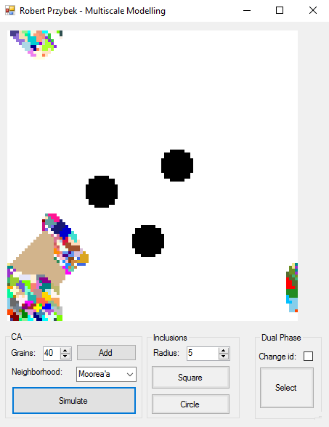

You can see above colours has been added and simulation has been works fine. Also grey colour what you before simulation marked you see still in the picture. If you want add grains in selected area you must unmark “Change ID” filed and add number of grains.

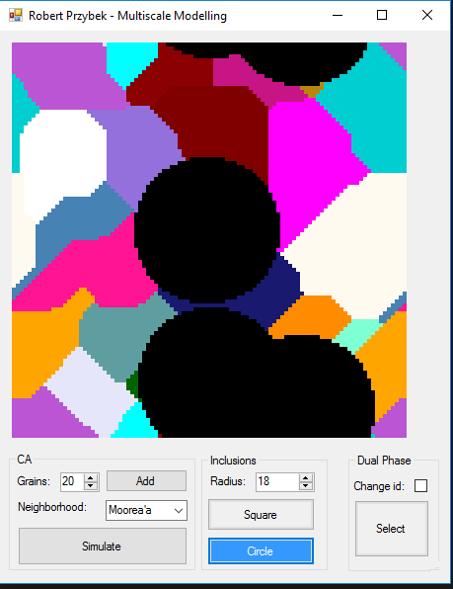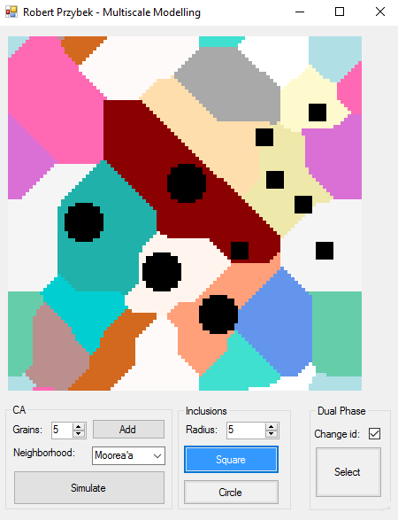

My last implementation is add some square and circle objects on screen. You can choose radius and size of those objects.

Summary

In the summary I would like to say is I did what I know. My program works good, fast and optimalizated. A several requirements has been implemented and some not, but I think this project was very good, and I did all what I can.